ELCT 371: Fall 2022

Homework #2 (based on Chapter 2)

Topics covered: Inverting and non-inverting op-amps, summing point constraint, Gain vs. frequency, op-amp limitations.

Due: September 22, 2022 Total Points = 80
- Each of the circuits shown in Figure P2.10 employs negative feedback. Assume that the op amps are ideal and use the summing-point constraint. Analyze the circuits to find the value of Vo for each circuit.
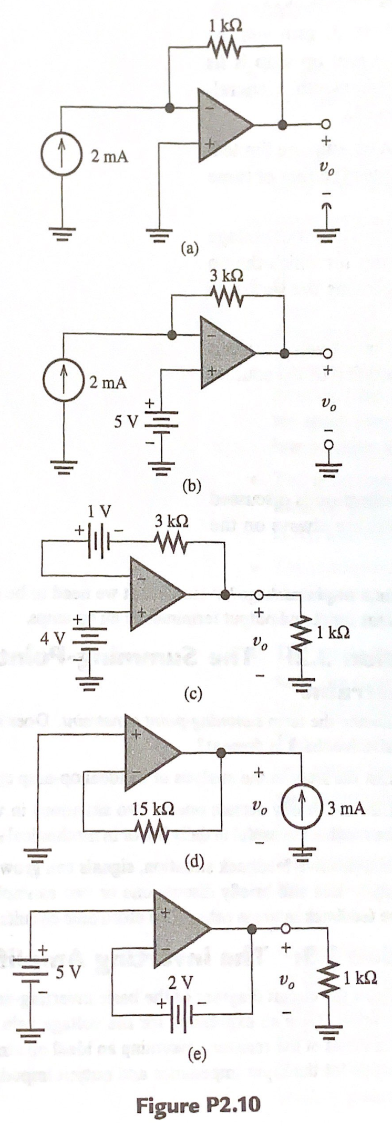

- Determine the closed-loop voltage gain of the circuit shown in Figure P2.14, assuming an ideal op amp. All of the resistors are equal in value.
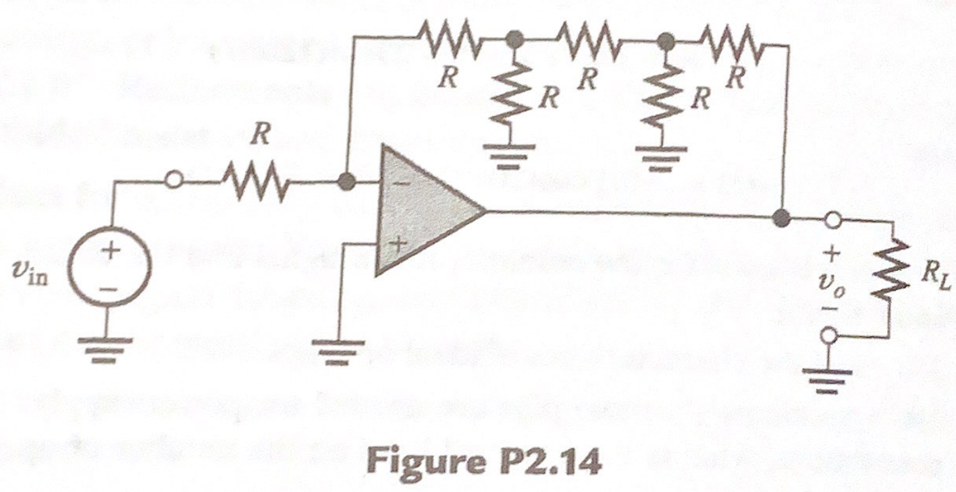
- The circuit shown in Figure P2.18 employs negative feedback. Use the summing-point constraint (for both op amps) to derive expressions for the voltage gains A₁ = vo₁ / v_{in} and A₂ = vo₂ / v_{in.}
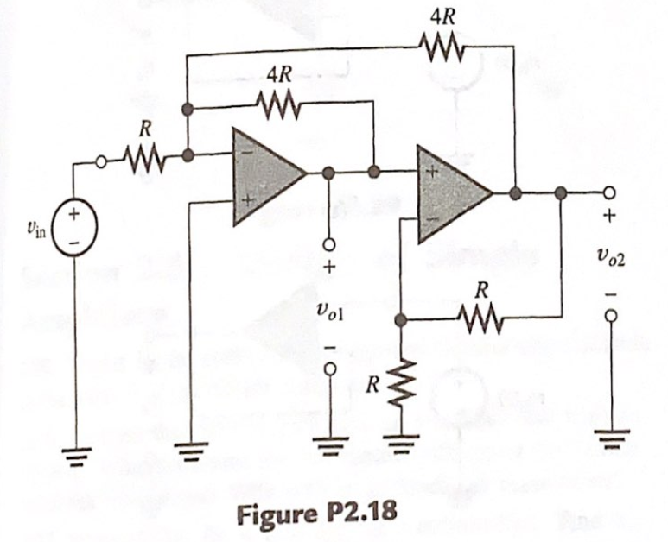

- Find an expression for the power gain of each of the amplifiers shown in Figure P2.24, Assume ideal op amps. Which circuit has the higher power gain?
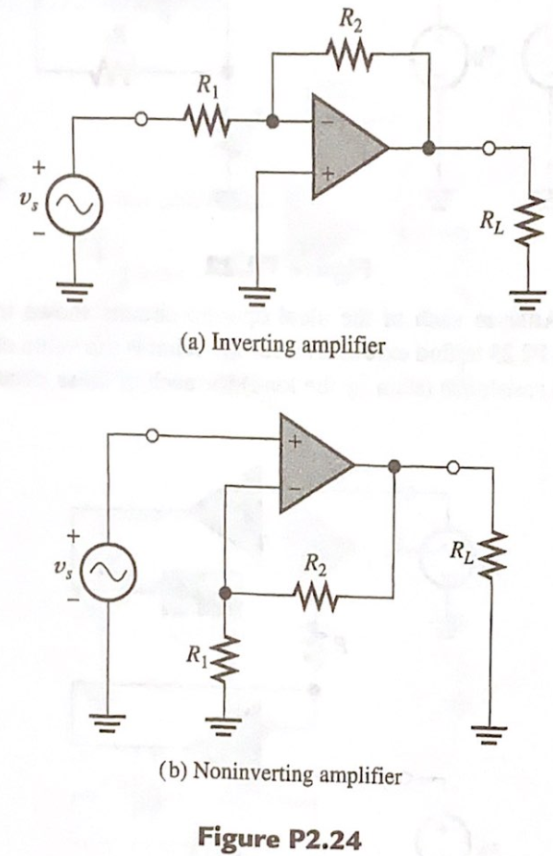
5. Consider the circuit shown in Figure p2.25.
- Find an expression for the output voltage in terms of the source current and resistor values.
- What value is the output impedance of this circuit?
- What value is the input impedance of this circuit?
- This circuit can be classified as an ideal amplifier. What type of amplifier is it? (See Section 1.9 for a discussion of various ideal-amplifier types.)
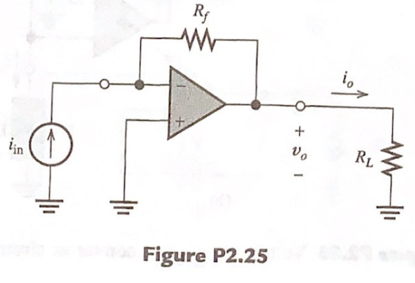
- A certain internally compensated (dominant pole) op amp has a dc gain of 200,000 and 3 dB bandwidth of 5 Hz. Sketch the Bode plot of the magnitude of the open loop gain to scale. If this op amp is used in a non-inverting amplifier having a closed loop dc gain of 100, sketch the bode plot of the magnitude of the closed loop gain to scale. Repeat for a closed-loop dc gain of 10.
- A certain op amp has a maximum output voltage range from -10V to +10V. The output can source or sink a maximum current of 20mA. The slew-rate limit is SR = 10V/us. This op amp is used in the circuit of Figure 2.32.
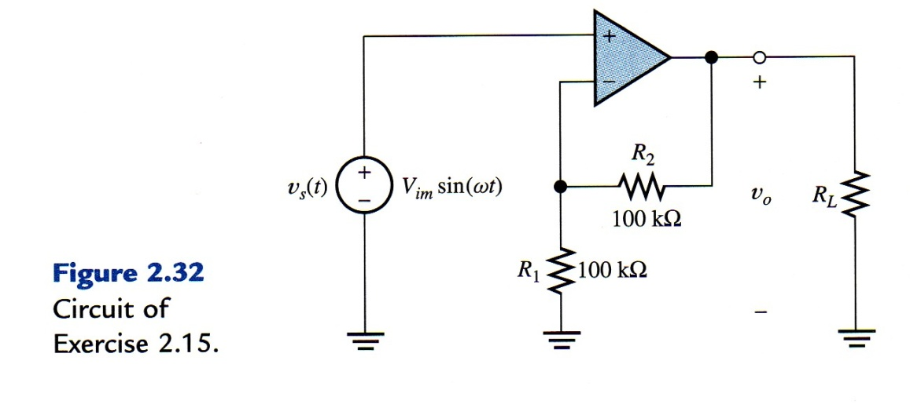
- Find the full-power bandwidth of the op amp.
- For a frequency of 1 kHz and R _{L} = 1 KΩ, what peak output voltage is possible without distortion?
- For a frequency of 1 kHz and R _{L} = 100 Ω, what peak output voltage is possible without distortion?
- For a frequency of 1 MHz, R _{L} = 1 KΩ, what peak output voltage is possible without distortion?
- If RL = 1 kΩ and Vs(t) = 5sin(2n10⁶ t), sketch the output waveform to scale against time.
- An op amp has a maximum output voltage range from -10 V to +10 V. The output can source or sink 25 mA. The slew-rate limit is 1 V/us. The op amp is used in an inverting amplifier configuration with R2 = 100 KΩ and R1 = 10 KΩ.
- Find the full-power bandwidth of the op amp.
- For a frequency of 5 kHz and R_{L} = 100 Ω, what peak output voltage is possible without distortion?
- For a frequency of 5 kHz and R_{L} = 10 KΩ, what peak output voltage is possible without distortion?
- For a frequency of 100 kHz, R_{L} = 10 KΩ, what peak output voltage is possible without distortion?

